PSlogo_mid

**User Privilege**

**User Manual**

***Version: 1.0***

*Date: 12-Nov-2013*

**Document History**

|  |  |  |  |  |
| --- | --- | --- | --- | --- |
| Date | Version | Description | Prepared by | Reviewed By |
| 12-Nov-2013 | 1.0 | Initial Draft Prepared | Sulochana Panta |  |

**Table of Contents**

[1. Introduction 1](#_Toc371683823)

[2. Types of Users 1](#_Toc371683824)

[2.1. Farrms Admin 1](#_Toc371683825)

[2.2. Application Admin User 1](#_Toc371683826)

[2.3. Security Admin User 4](#_Toc371683827)

[2.4. Report Admin User 5](#_Toc371683828)

[2.5. Normal User without User and Roles privilege 5](#_Toc371683829)

[2.6. Normal User with User and Roles privilege 5](#_Toc371683830)

[3. Usage 6](#_Toc371683831)

[4. User Privileges 7](#_Toc371683832)

[5. Test Case 11](#_Toc371683833)

# Introduction

FARRMS application is a role-based, data-level security model. Users are assigned with various types of roles to access particular functionalities within the system. Currently, there are six types of users available that are assigned with different roles/privileges.

This document describes about the user types and their roles/privileges in the application.

# Types of Users/Role Types:

Following are the types of Users/ Role Types are available in FARRMS application:

## Farrms\_Admin

This is a default super user which has unrestricted access to all the modules and functionality of the whole application.

## Application Admin Group

Generally, FARRMS application has a default super user farrms\_admin which has unrestricted access to all the modules and functionality of the whole application. But some applications uses windows authentication to connect to the underlying database so the farrms\_admin login can't be used here to access the application as farrms\_admin windows user will not be available and normally client refuses to create one just to use it for FARRMS application. Thus, to overcome this issue, a new system defined role type with unrestricted access to the application called **Application Admin Group** was created. This role type has all the privileges that the super user **farrms\_admin** has such that the farrms\_admin user can be omitted from the system.

### Procedure of creating Role with Application Admin Group Role Type and assigning Role to the user

Once the users are created, these users must be assigned to particular role to access the functionalities of the application. To assign the role/privileges to the users of the FARRMS application, follow the steps below:

* Go to Users and Roles>>Maintain Roles
* Following form should open using which roles can be created.

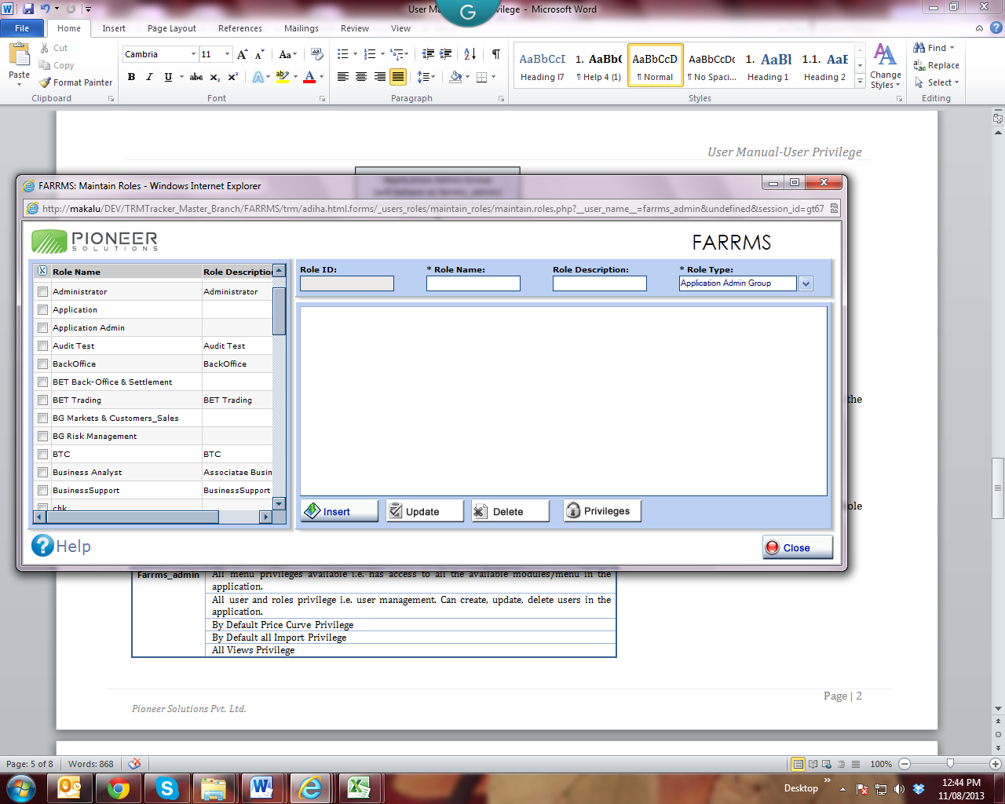

* Click on Insert button.
* Enter **Application Admin** in Role Name.
* Select **Application Admin Group** from the Role Type dropdown.
* Click on Update button to save the Role.

In this way, Role with the Application Admin Group Role Type is created. To create other Roles with Security Admin Group or Reporting Admin Group role type, repeat the same steps as above and select Security Admin Group or Reporting Admin Group in Role Type dropdown for Security Admin Group or Reporting Admin Group respectively.

After creating the role, it has to be assigned to the user. For this following steps need to be followed:

* Go to Users and Roles>>Maintain Users.
* Following Form should open using which role can be assigned to the particular user.

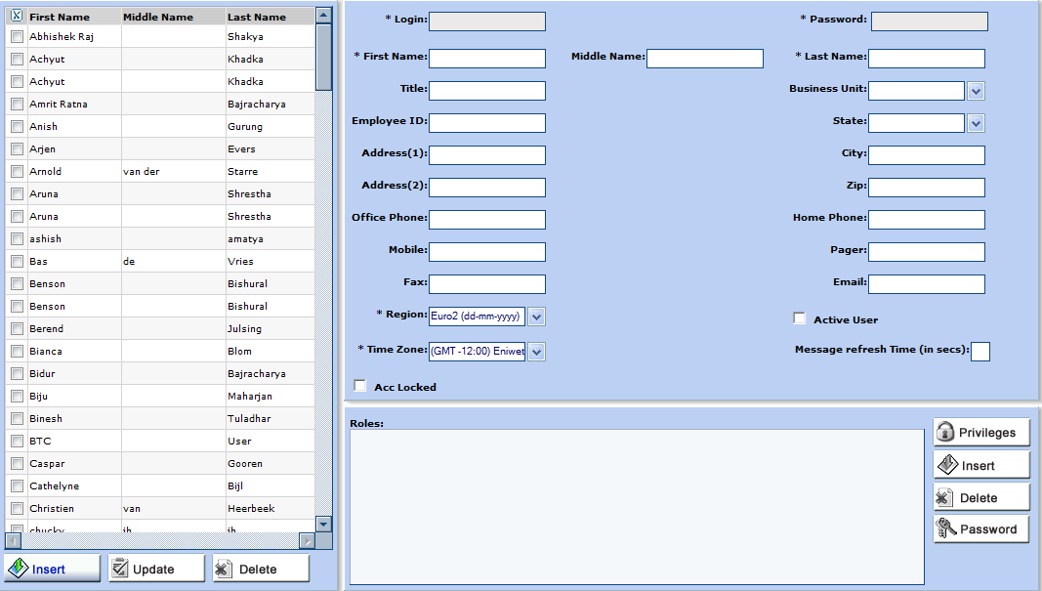

* Click on Insert button.
* Enter ‘Adminuser’ in Login Field, Enter ‘pioneer’ in Password Field, Admin in First and ‘User’ in Last name field respectively.
* Check on Active checkbox.
* Click on ‘Update’ Button.
* Select ‘Admin’ from the user grid.
* Click on Insert button on the Roles grid.
* **Select Roles** Form should open using which roles to be assigned can be selected for a particular user.

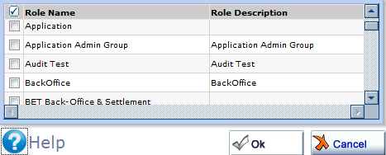

* Select **Application Admin Group** Role from the Role grid.
* Click on Ok button on the page.
* Click on Ok button on the dialog box.
* Selected Role should be displayed in Roles grid of the Maintain Users page.

This way User is assigned with the Application Admin Group Role. Repeat the same steps as above to assign other role to particular user. One or more than one role can also be assigned to the same user depending upon the requirement. For this, multiple role names should be selected on the grid of **Select Roles** window.

After logging in to the application from the ‘Adminuser’, this user should have unrestricted access to the whole application. (This is dealt in detail in User Privilege section)

## Security Admin Group

This role type has unrestricted access to the entire Users and Roles module that means it can manage all the users in the system including privilege of Book Structure.

### Procedure of creating Role with Security Admin Group Role Type and assigning Role to the user

* Follow the same procedure as in Application Admin Group but enter **Security Admin** in Role Name and select **Security Admin Group** from the Role Type dropdown while creating the role and assign the **Security Admin** role to ‘Adminuser’ .

After logging in to the application from the ‘Adminuser’, this user should have unrestricted access to user and role module along with privilege of Book Structure. (This is dealt in detail in User Privilege section)

## Reporting Admin Group

This role type has unrestricted access to the 4 menus in the Reporting module i.e. Report Writer, Report Group Manager, Run Report Group and Report Manager along with privilege of Book structure.

### Procedure of creating Role with Reporting Admin Group Role Type and assigning Role to the user

* Follow the same procedures as in Security Admin Group but enter **Reporting Admin** in Role Name and select **Reporting Admin Group** from the Role Type dropdown in creating the role. Map **Reporting Admin** role to the ‘Admin’ user as in Security Admin Group.
* Selected Role should be displayed in Roles grid of the Maintain Users page.

After logging in to the application from the ‘Adminuser’, this user should have unrestricted access to 4 menus in the Reporting module i.e. Report Writer, Report Group Manager, Run Report Group and Report Manager along with privilege of Book structure. (This is dealt in detail in User Privilege section)

## Normal User (without User and Roles privilege)

This is the user who does not falls under Application Admin Group or Security Admin Group or Reporting Admin Group and this type of users does not have the maintain user privileges.

The maintain user menu should still be active for the user. The user grid should list own user only and should be able to update its profile and change the password.

### Procedure of creating Normal User without Users and Roles Privilege

* Go to Users and Role >>Maintain Roles.
* Click on Insert button.
* Enter **Non-Privileged Normal User** in Role Name.
* Select **Control Group** from the Role Type dropdown.
* Click on Update button to save the Role.
* Select the **Non-Privileged Normal User** from Roles grid and click on **Privileges** button.
* Click **Insert** button on the Maintain Roles Privileges page.
* Select all function ID except the Function ID from **10111000-10111114** which is related with the Users and Roles on **Select Privileges** window and click **OK** button.
* Repeat the same steps as above in section 2.2.1. to assign **Non-Privileged Normal User** role to ‘Adminuser’ user.

After logging in to the application from the ‘Adminuser’, this user should have access to update the profile and password of ‘Adminuser’ only. (This is dealt in detail in User Privilege section)

## Normal User (with User and Roles privilege)

This is the user who does not falls under Application Admin Group or Security Admin Group or Reporting Admin Group .The privilege of Users and Role are assigned manually. This type of users can then access the Maintain User and Maintain Roles menus.

As the Maintain User(**10111000**) privilege is assigned to the user; thus the user should be able to view all the avaiable users in the application in its user grid. All other insert user, update user, privilege button should be active or deactive depends on the privilege assigned or not.

### Procedure of creating Normal User with Users and Roles Privileges

* Repeat the same steps as in 2.5.1. but enter **Normal User** in Role Name and select all available privileges including Function ID from **10111000-10111114.** Assign ‘Adminuser’ to the **Normal User** role. Note that each function ID has distinct privilege.

# Usage

Application Admin Group's scope is the whole application, i.e. it has unrestricted access to the whole application. But if unrestricted application is required for only some modules, then another role type can be created. For e.g. at the current moment, FARRMS application already has two such role types named **Security Admin Group** and **Reporting Admin Group**. The former has unrestricted access to **User and Roles** module only and the latter has similar access to **Report Manager** Module only. The relation among these role types can be better understood by following figure.

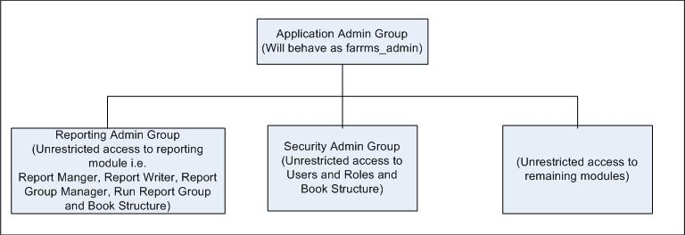

# User Privileges

The privileges for modules and functionality that are applicable for various users in the application are given below in details.

|  |  |  |
| --- | --- | --- |
| User/Role Type | Roles/Privileges | Description |
| Farrms\_admin | All menu privileges | This user has unrestricted access to all the available modules/menu in the application. All menu and sub-menus should be enabled. |
| All user and roles privilege | It is related with user management. Firstly, it can view all the users available in the system.This user can create, update, delete other users in the application. It has privilege to change time zone, password, region, insert/update/delete privileges and roles etc of all the user existing in the system. It can unlock the locked user. It can activate or deactivate the user. |
| By Default Price Curve Privilege | All available price curves must be visible to this user in Setup Price Curve, View Prices, in the combo box of Index and so on without assigning privilege to this User or Role from Privilege Tab in Setup Price Curve Detail page. Also this user can use all the available price curves in Deals, Deal Templates and in all forms having Price/Index Field. |
| By Default all Import Privilege | This user has unrestricted access to import all data i.e import from system file, import from source system and import from custom file. It can perform all types of import process in the application. |
| All Views Privilege | This user has unrestricted access to view all available reports-system and general in the system and run, export all available reports (this includes reports prepared by another users as well) in different formats. |
| All Book Structure Privilege | This user has unrestricted access to view and use all the available book structure(Subsidiary/Strategy/Book and Subbook) in portfolio hierarchy in Maintain Transaction. |
| All jobs manageability privilege | This user has unrestricted privilege to view scheduled job by all other users in view scheduled job. However, Batch Job created by other users can not be Edited, Run and Deleted. |
| Newly added Menu | This user has unrestricted access to the newly added menu forms in the application without assigning privileges. |
| All Deal template privileges | This user has unrestricted privilege to view, update, copy and delete available Deal Template (inserted by other users too) in the system. This user can create new Deal Template and transfer Deal. All available Deal templates should be listed in the Deal Template Dropdown in Deal Blotter page and all other page with this Field. |
| Workflow Group dropdown | For this user, all the roles should be listed in Workflow Group dropdown of My Workflow Tab and in Maintain Workflow Menu Page. |
| My Reports Roles dropdown | For this user, all available roles should be listed in My Reports Roles dropdown of My Reports Tab and in Maintain Report Page. |
| By Default privilege of all Price Curves in Copy Price UI | All the price curves should be listed in Price Curve grid of Copy Price UI without assigning privilege to this User or Role from Privilege Tab in Setup Price Curve Detail page. |
| By Default privilege of Price Curve in Location Detail | All the price curves should be listed in Spot Pricing Index and Term Pricing Index dropdowns in Location Detail page without assigning privilege to this User or Role from Privilege Tab in Setup Price Curve Detail page. |
| By Default Privilege of all Export/Import rule | All the Rules defined in system should be listed in the grid in Data Import/Export Manager without giving privilege to this user. |
| By Default privilege of all the reports in report manager and report writer | This users has unrestricted access to all the reports existing in the system. All reports can be created, viewed, updated, copied, deleted and exported in all the formats in Report Writer page and in Report Manager Page. Also, privilege for the reports can be assigned for any users. |
| By default privilege of report manager and tree structure filter privilege | This user has unrestricted access to portfolio hierarchy and all other filters in Report Criteria Page while exporting report in available format. |
| Report Group Manager | For this user, all application users are listed in Users Dropdown of Report Group Manager Page in Reporting Module. |
| Report Group Manager > Report Group Header IU | All application users should be listed in Users dropdown of Report Group Header IU. |
| Report Dashboard Template | All application users should be shown in the Users dropdown of the Report Dashboard Template page. |
| Report Dashboard Template > Report Dashboard Template IU | All application users should be shown in the Users dropdown of the Report Dashboard Template IU page. |
| Application Admin Group | Same as farrms\_admin | Similar to Farrms\_Admin |
| Security Admin Group | By default privilege of user management (maintain user) | It is related with user management i.e Users and Roles module. Firstly, it can view all the users available in the system.The user with this role type can create, update, delete all applicaton users(including self) in the system. It has privilege to change time zone, password, region, insert/update/delete privileges and roles etc of all the user existing in the system. It can lock or unlock and activate or deactivate all application users in the system. |
|  | By default privilege of Roles | The user with this role type has unrestricted access to view all available roles in the system. It can create, update, delete and assign privilege for respective role. |
|  | Book Structure Privilege | The user with this role type has unrestricted access to the Portfolio hierarchy(Subsidiary, Strategy and Book) in Select Priviliges Page. |
|  | Workflow Group dropdown | Mapped roles to this user and My Workflow should be listed in Workflow Group dropdown of My Workflow Tab. |
|  | My Reports Roles dropdown | Mapped roles to this user including My Reports should be listed in My Reports Roles dropdown of My Reports Tab. |
| Reporting  Admin Group | By Default Report Writer, Report Group Manager, Run Report Group and Report Manager Privilege | The user with this role type has unrestricted access to Report Writer, Report Group Manager, Run Report Group and Report Manger. All these menu should be enabled to this role type. |
| All new and old report privileges | The user with this role type has unrestricted access to view old and newly created reports in the Report Manager Page. All reports should be available by default. |
| By default privilege of report manager and tree structure filter privilege | All Book Structure privilege should be available in report filter while executing report writer and report manager report. |
| Privilege of Maintain User | The user with this role type has unrestricted access to view, update time zone and password of the same(logged) user. |
| Report Group Manager | For the user with this role type, all application users are listed in Users dropdown in Report Group Manager page in Reporting module. |
| Report Group Manager > Report Group Header IU | For the user with this role type, all application users are listed in Users dropdown in Report Group Header IU in Reporting module. |
| Report Dashboard Template: Shows all application users in Users dropdown. | For the user with this role type, all application users are listed in Users dropdown in Report Dashboard Template in Reporting module. |
| Report Dashboard Template > Report Dashboard Template IU | For the user with this role type, all application users are listed in Users dropdown in Report Dashboard Template IU in Reporting module. |
| Workflow Group dropdown | Mapped roles to this user and My Workflow should be listed in Workflow Group dropdown of My Workflow Tab. |
| My Reports Roles dropdown | Mapped roles to this user including My Reports should be listed in My Reports Roles dropdown of My Reports Tab. |
| Normal User (without User and Roles privilege) | Maintain Users | This user should not have privilege of User and Role management. However, maintain user menu should be active. But, only the logged user should list in the grid and it can change its own profile and Password only. This user can lock or unlock it own account but can not activate or deactivate the account. |
|  | Workflow Group dropdown | Mapped roles to this user and My Workflow should be listed in Workflow Group dropdown of My Workflow Tab and in Maintain Workflow Menu Page. |
|  | My Reports Roles dropdown | Mapped roles to this user including My Reports should be listed in My Reports Roles dropdown of My Reports Tab and in Maintain Report Page. |
|  | Job Manageability Privilege | The user with this role type has unrestricted access to the view, update and run the job created by logged in User. |
| Normal User (with User and Roles privilege) | Maintain Users | This user has a privilege of User and Role management. Maintain User and Maintain Roles menu should be active. All available application user is visible to this user. It can update profile, change password, assign/delete Privilege/Role to all application users including self. |
| Book Structure Privilege | This user should have privilege of portfolio hierarchy i.e. Subsidiary, Strategy and Book should be displayed in Select Privileges page. |
| Workflow Group dropdown | Mapped roles to this user and My Workflow should be listed in Workflow Group dropdown of My Workflow Tab and in Maintain Workflow Menu Page. |
| My Reports Roles dropdown | Mapped roles to this user including My Reports should be listed in My Reports Roles dropdown of My Reports Tab and in Maintain Report Page. |
| Job Manageability Privilege | The user with this role type has unrestricted access to the view, update and run the job created by logged in User. |

# Test Case

The test case for the user and privilege is attached in the excel sheet as given.

